Domestic Sponsor: Four Peaks Rotary Club, Fountain Hills, Airzona
International Sponsor: Club Rotario Merida Itzaes, Yucatan, Mexico
The Rotary Foundation Global Grant #GG2092485
NAVAJO WATER ARIZONA PROJECT STRATEGIC PLAN
Organization Mission Statement:
Navajo are 67 times more likely than other Americans to live without running water or a toilet. That's an injustice. Many Natives can't get enough clean water, creating a cycle of poverty that limits health, happiness, educational opportunity, and economic security.
As Rotarians, we can fix that. With financial assistance of global grants from The Rotary Foundation, Rotary Clubs in Arizona, Oklahoma, Mexico, Canada and India have already installed over fifty running water systems over the past two years in Navajo homes in New Mexico. We now propose to continue that work in the Dilkon Chapter of Navajo Nation in Arizona and we are asking for your help.
Why Dilkon Chapter?
Dilkon Chapter (To’alch’idi) is a certified chapter in the southwestern region of the Navajo Nation. It’s name means “small amount of water.” With a population of just over 2,200 spread over 1,526 square miles, in the northeast corner of Arizona, this arid high desert suffers from extreme water poverty. The community has undergone an extensive study of community needs. There are at least 160 households which have no running water, which are more than 30 minutes round trip away from the nearest water station and whose household members are unable to fetch water or store in in their homes due to age, infirmity and lack of storage facilities.
Why Rotary?
Although the federal government is legally obligated to assure the availability of safe drinking water to all American Indians and Alaska Natives, it has not done so due to “economic infeasibility.” (Report to Congress by Sanitation Facilities Construction Division, Office of Environmental Health, Indian Health Service, 2018) The weather at high elevation (5,985 feet above sea level), topography and subsoil conditions make establishing a piped water grid nearly impossible. In nearly 50% of the cases where serious water quality deficiencies have been identified, often rural areas which rely on private water sources and have the most serious health issues and highest repair costs, no money is allocated by the government. (Ibid.; GAO, Drinking Water and Wastewater Infrastructure, May, 2018, pp. 6, 29 ) That means that private funding will be necessary to tackle this urgent problem. Despite an estimated cost of $2.7 billion to address serious water and sanitation infrastructure issues in all eligible homes on Native American reservations, Congress appropriated only 4% of that amount in 2016. The total budget for 2019 was $2 billion less that the amount spent in the prior year. (Arizona Republic article Dec. 26, 2018, citing a Report by the U.S. Commission on Civil Rights)
What We Propose:
The Navajo Water Arizona Project seeks funding to continue existing and on-going efforts by DigDeep, a Los Angeles based non-profit organizations, to provide clean, running water to approximately 160 Navajo American families living within the Dilkon Chapter. DigDeep has helped provide a second delivery truck and plan for construction of individual water systems to Navajo homes, including 1200 gallon underground cisterns and the necessary equipment to make home delivery more efficient for Navajo families. A solar panel, battery and electrical connections are included for families which do not have electrical service in order to operate the pump.
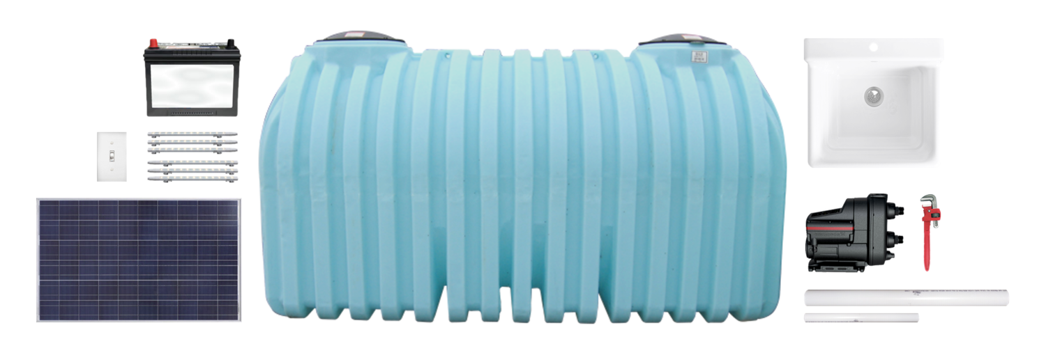
Figure 1 Running Water and Solar Power for $4,500

How It Works:
Construction of each home water system is performed by employees and local contractors of DigDeep at a fixed cost of $4,500, including excavation, installation, materials, solar panel equipment and home training to operate. No portion of the price goes toward overhead or general operating expenses.
Construction proceeds at a rate of approximately 2½ systems completed each week and is planned to begin in Dilkon just after January 1, 2020. It will require approximately $720,000 to complete the 160 home system installations. The Four Peaks Rotary Club from Fountain Hills, Arizona, is the domestic host on the global grant, with Club Rotario Merida Itzaes from Yucatan, Mexico, serving as the international host. District 5280 in the Los Angeles area is partnering with District 5495 in Arizona to make this project work, along with other Rotary Clubs in the Phoenix area, across the United States and around the world.
Except for a service charge of 5% by TRF, 100 per cent of the solicited funds will go toward construction of the individual home water systems and not to program administration.
What We Seek:
Four Peaks Rotary Club and Districts 5280 and 5495 are seeking Rotary Club partners in Arizona, California, Mexico, South Korea and around the world to support a global grant from the world fund and matching funds from the respective Rotary Districts to pay as much of the cost as possible. The current global grant budget, with international funding of 30% of the total cost, is as follows:
160 units x $4,500 = $720,000
70% Domestic Contributions
Rotary Clubs $168,000
Rotary Districts (DDF) $ 84,000
Total Domestic $252,000
30% Required International
Rotary Clubs $ 72,000
Rotary Districts (DDF) $ 36,000
Total Int’l $108,000
Global Grant match $360,000

This project meets the Rotary objectives of serving a dire community need, with international assistance for the benefit of Navajo families, including their children.
The Navajo Water Project is sustainable by the ongoing support of DigDeep and the Dilkon Chapter tribal authority by supplying reliable clean water at affordable cost through the use of durable and reliable home water systems. The efficiency of the existing home water delivery system will be improved by increasing capacity and ease of each delivery. The Navajo families will have a more adequate supply of clean water to sustain them between deliveries.
By setting an example, Rotary will allow DigDeep to attract other donors.
This is a “shovel-ready” project. Rotary was not involved in the selection process of families which who receive systems and is not involved in any construction issues. A certificate of completion will be provided to Rotary within two weeks of each installation, verifying use of the Rotary funds and identifying the specific beneficiaries. Opportunities will exist for publicity as deemed appropriate.
Additional information can be found at the following websites:
http://www.navajowaterproject.org/
https://video.search.yahoo.com/search/video?fr=mcafee&p=pbsnewshour+off+the+grid#id=1&vid=b220dd04004ac906b9d4d49de990c24c&action=click
https://www.gao.gov/assets/700/691757.pdf
https://www.ihs.gov/sites/newsroom/themes/responsive2017/display_objects/documents/Report_To_Congress_FY18_SanitationFacilitiesDeficiencies.pdf

